[ZANG] - [Chuanjie] - ITCAssignment

Student ID: 699382953

[chuanjiezang@gmail.com](mailto:chuanjiezang@gmail.com)

**Assignment 1: Green Acres Technical College**

**Part 1.**

Design a program for Green Acres Technical College to handle the tuition calculations for the school. The current tuition is $20,000 per year, and tuition is expected to increase by 3 percent each year. Display the tuition each year for the next 10 years.

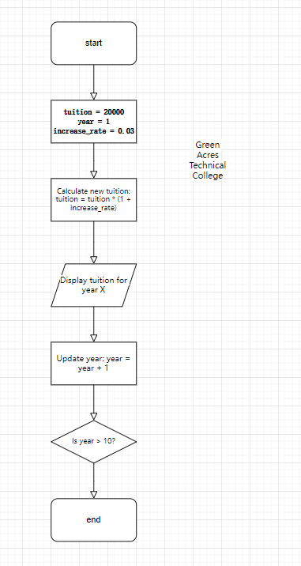

**Part 2.**

Modify the Green Acres Technical College program so that the user enters the rate of tuition increase instead of having it fixed at 3 percent per year

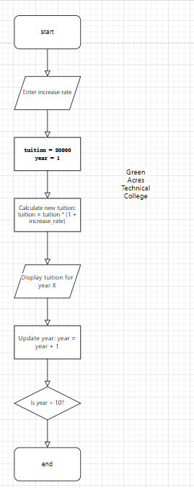

**Part 3.**

Modify the Green Acres Technical College program so that the user enters the rate of tuition increase for the first year. The rate then increases by 0.5 percent each subsequent year.

